Renju lesson on March 1, 2001

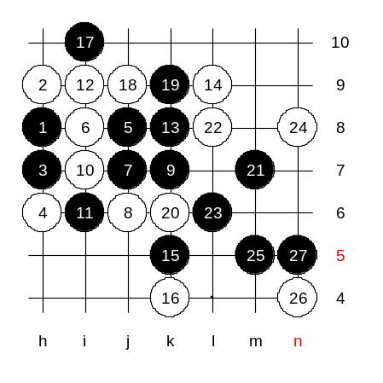
Hello all! Welcome to Online Renju Class. We will begin the lesson. It is time to learn about the third choice of the 5th move. This move is weaker than the previous two 5th moves we learned. But it still gives black good advantage. What is the next white move here? I am sure some of you have played it already. Many of you suggested i8. Actually it is a bad move. Let’s find out why. White is too passive, and without any chance to counter-attack. In such case black controls the game easily. How can white block now? Black seems so strong. Ok, we try 8-j6. Black has an interesting choice on 9th move. Both k7 and i6 are important points for black. My thinking is, if black plays i6, and white cannot take the k7 point, then the i6 move is good. But if after white’s block at k7 there are problems with black attack, then we must consider playing black three to k7 first and then to i6. Do you agree that black cannot win without using the i6 point? Do you agree that if we play to i6, and if white cannot play to i9, then black does not need to play to i9 too soon? If so, then this is the answer to ppipp’s question why we did not play k7 and i9. But if white can take i9, then black should have taken i9 first. This is our chance to find out. We test i9 now. This is the way you have to think of almost every move in your real games. Do not use too many threes or fours unless it is necessary. And we will check if black’s three to j9 was necessary or not. If not necessary, then we do not have to play it. How about 17-i10? Defense move, but yet so powerful because it connects the f9 force. Now white is in trouble. We try white’s defense move j9. White has tempo now, but it has nothing to do with that tempo because there is no defense already. Please suggest the white block now.

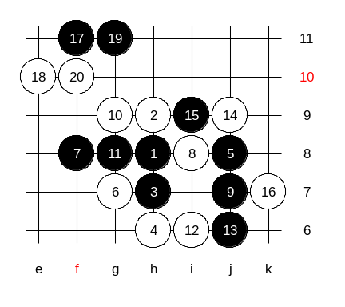
Now, lets study about some stronger 6th move. Moves 6-g8 and 6-g7 are much stronger. Yes, they are outside, and active, therefore they are stronger moves. Move 6-g7 is quite popular. Lets study it first. We will show the old style first, and make sure it is not so good for black, and after that we will learn about better 7th move. The old style begins with 7-f8. The following moves are the strongest for both sides. Black can have some attack on the left and upper side, but it is weak, and fails soon. As a result, white will have a very good position. Lets test the example attack, and make sure how white block’s it easily. By the 20th move, white has blocked everything. Black is unable to continue successful attack.

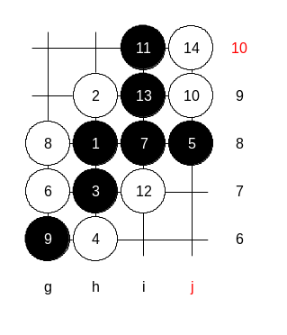
Now, we saw that the old style was quite poor, and therefore we take a look at modern 7th move. It begins with straight style. Although we learned that using threes and fours is not a good idea, but we do it when it is necessary. Here it is necessary. Black uses the threes to balance black and white structures. There are 11 stones on the board now. This is the standard theory of this 5th move. Remember it. Which white moves are possible here? I know at least three of them. ASV is curious about i7, lets try it.
Here is my suggestion. This is the advanced level homework. Please find the black win.

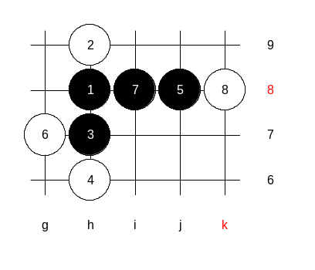

This is the medium level homework. Please find the black win.

Thank you all for coming to lesson. See you all next week. Have a good day/night! ^_^

